**Project Report**

**On**

**BUCK CONVERTER & BOOST CONVERTER**

*submitted towards the partial fulfilment of*

*the requirement for the award of the degree of*

**Bachelor of Technology**

In

**Electrical Engineering**

Submitted by

**Ritul**

**2K20/EE/221**

Under the Supervision

Of

**Dr.** **Ashish Kulkarni**

Delhi Technological University

Bawana Road. Delhi -110042

DELHI TECHNOLOGICAL UNIVERSITY

(FORMERLY Delhi College of Engineering) Bawana Road, Delhi-110042

## CANDIDATE’S DECLARATION

I, **Ritul (2K20/EE/221)** student of B. Tech. hereby declare that the project titled ‘**Buck Converter & Boost Converter’** which is submitted by us to the Department of Electrical Engineering, Delhi Technological University, Delhi in partial fulfilment of the requirement for the award of the degree of Bachelor of Technology, is original and not copied from any source without proper citation. This work has not previously formed the basis for the award of any Degree, Diploma Associateship, Fellowship or other similar title or recognition.

**Ritul**

**2K20/EE/221**

DELHI TECHNOLOGICAL UNIVERSITY

(FORMERLY Delhi College of Engineering) Bawana Road, Delhi-110042

## CERTIFICATE

I hereby certify that the project titled ‘**Buck Converter & Boost Converter’** which is submitted by, **Ritul (2K20/EE/221)**  of Delhi Technological University, Delhi in complete fulfilment of the requirement for the award of the degree of the Bachelor of Technology, is a record of the project work carried out by the students under my supervision. To the best of my knowledge this work has not been submitted in part or full for any Degree or Diploma to this University or elsewhere.

Place: Delhi **Dr. Ashish Kulkarni**

**SUPERVISOR**

DELHI TECHNOLOGICAL UNIVERSITY

(FORMERLY Delhi College of Engineering) Bawana Road, Delhi-110042

## ACKNOWLEDGEMENT

In performing our major project, we had to take the help and guideline of some respected persons, who deserve our greatest gratitude. The completion of this assignment gives us much pleasure. I would like to show our gratitude to **Dr. Ashish Kulkarni**, mentors for our project. Giving us a good guideline for the report throughout numerous consultations. I would also like to extend our deepest gratitude to all those who have directly and indirectly guided us in writing this assignment.

Many people our classmates and team members itself, have made valuable comment suggestions on this proposal which gave us an inspiration to improve our assignment. We thank all the people for their help directly and indirectly to complete our assignment.

In addition, we would like to thank Department of Electrical Engineering, Delhi Technological University for giving us the opportunity to work on this topic.

**INTRODUCTION**

**Buck Converter**

A buck or step-down converter is a DC/DC switch mode power supply that is intended to buck/lower the input voltage of an unregulated DC supply to a stabilized lower output voltage. Buck converters are, especially compared to traditional voltage regulators, widely valued for their extremely high efficiencies which can easily exceed 95%. The below simplified circuit diagram shows how current flows through the circuit during a switching event of a buck converter.

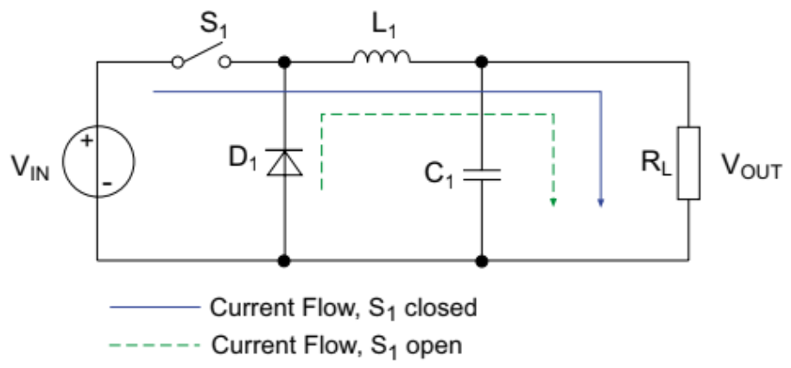

Buck converters have a number of applications some of which are as follows-

* USB On-The-Go
* POL Converter for PCs and Laptops
* Battery Chargers
* Solar Chargers
* Brushless Motor Controllers

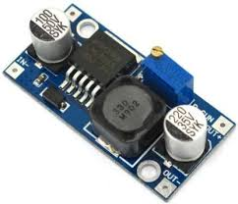

**Boost Converter**

A boost converter is a DC/DC switch mode power supply that is intended to boost/increase the input voltage of an unregulated DC supply to a stabilized higher output voltage. Similar to a buck converter, a boost converter relies on an inductor, diode, capacitor, and power switch regulate the output voltage, but they are arranged differently. The below simplified circuit diagram shows how current flows through the circuit during a switching event of a boost converter.

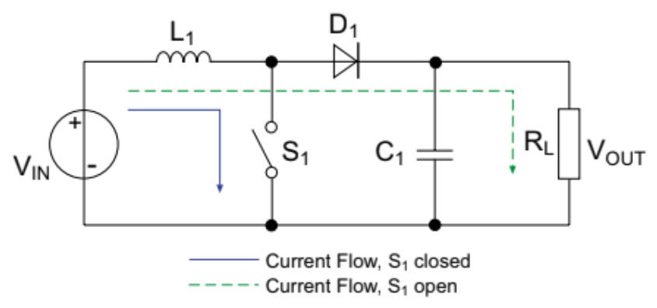

Even boost converters have quite a few applications ranging from-

* Automotive applications
* Power amplifier applications
* Adaptive control applications
* Battery power systems
* Consumer Electronics
* Communication Applications

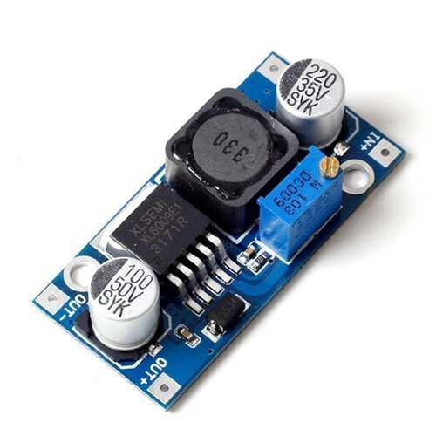

**COMPONENTS**

**IRF6215 MOSFET (Buck Converter)**

IRF6215 is a -150V Single P-channel HEXFET (Power MOSFET). It is a fifth Generation HEXFETs from International Rectifier utilize advanced processing techniques to achieve extremely low on-resistance per silicon area. This benefit, combined with the fast-switching speed and ruggedized device design provides the designer with an extremely efficient and reliable device for use in a wide variety of applications. It is universally preferred for all commercial-industrial applications at power dissipation levels to approximately 50 watts. The low thermal resistance and low package cost is an added benefit. It has an operating temperature up to 175 degrees Celsius.

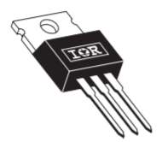

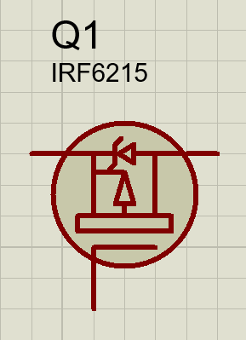

**IRF540N MOSFET (Boost Converter)**

IRF540N is 100V small signal N-Channel, Power MOSFET. It is an advanced HEXFET (Power MOSFET) from International Rectifier which utilizes advanced processing techniques to achieve extremely low on-resistance per silicon area. This benefit, combined with the fast-switching speed and ruggedized device design, provides the designer with an extremely efficient and reliable device for use in a wide variety of applications. It is universally preferred for all commercial-industrial applications at power dissipation levels to approximately 50 watts. The low thermal resistance and low package cost contribute to its wide acceptance throughout the industry. It has a maximum operating temperature of 175 degrees Celsius.

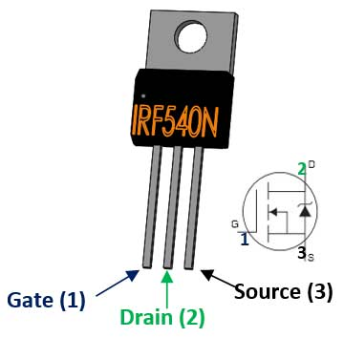

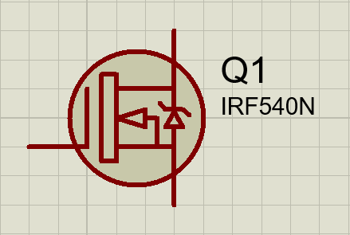

**6TQ045 Diode**

The 6TQ045 Schottky rectifier series has been optimized for low reverse leakage at high temperature. The proprietary barrier technology allows for reliable operation up to 175 °C junction temperature. Typical applications are in switching power supplies, converters, freewheeling diodes, and reverse battery protection. It is suitable for high frequency operation and low forward voltage drop. The maximum DC reverse voltage it can withstand is 45 V.

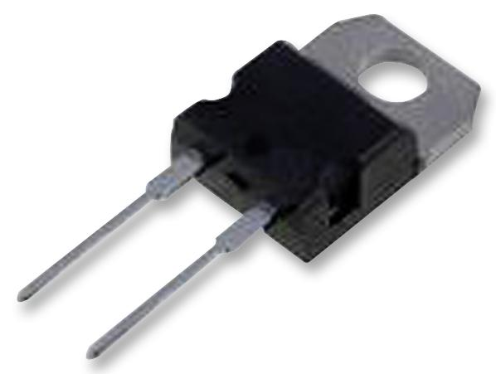

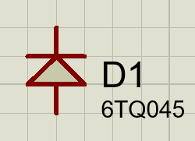

**Voltage Source-12V**

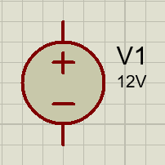

**Capacitor- 2X100uF**

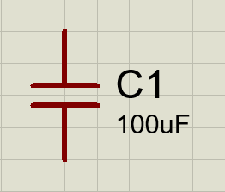

**Inductor-100uH**

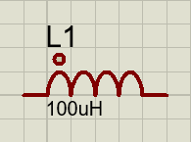

**Resistor-5ohm**

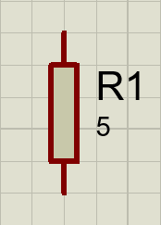

**Final Schematic- Buck Converter**

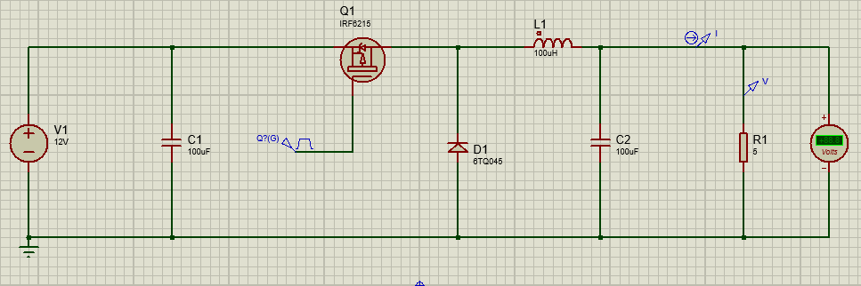

**Final Schematic- Boost Converter**

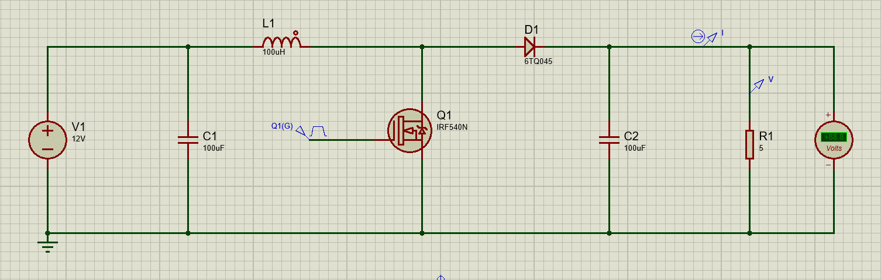

**SIMULATION**

**Buck Converter**

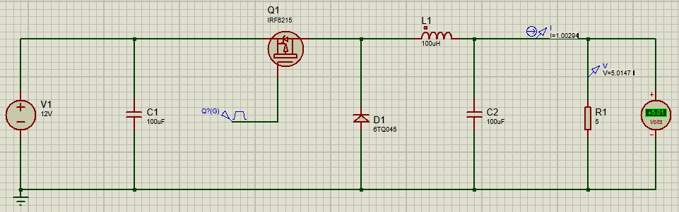

**Graph**

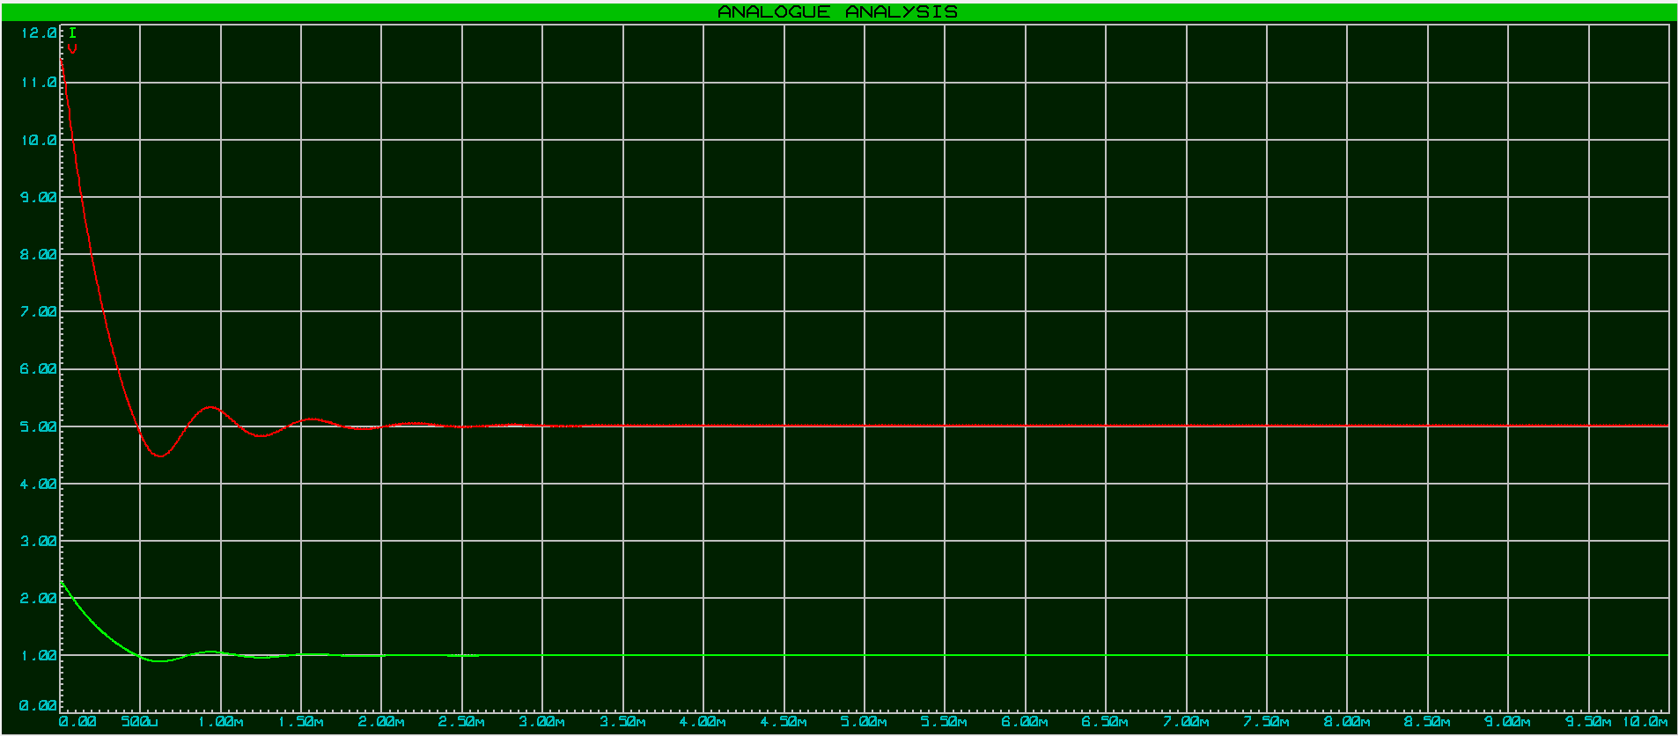

**Boost Converter**

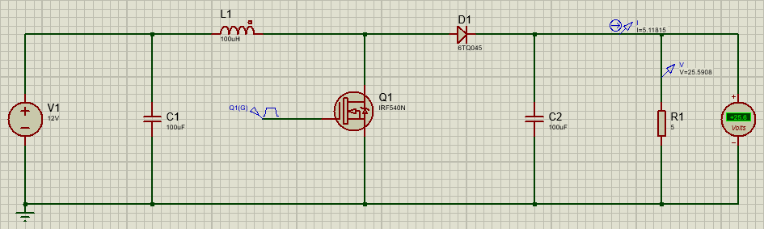

**Graph**

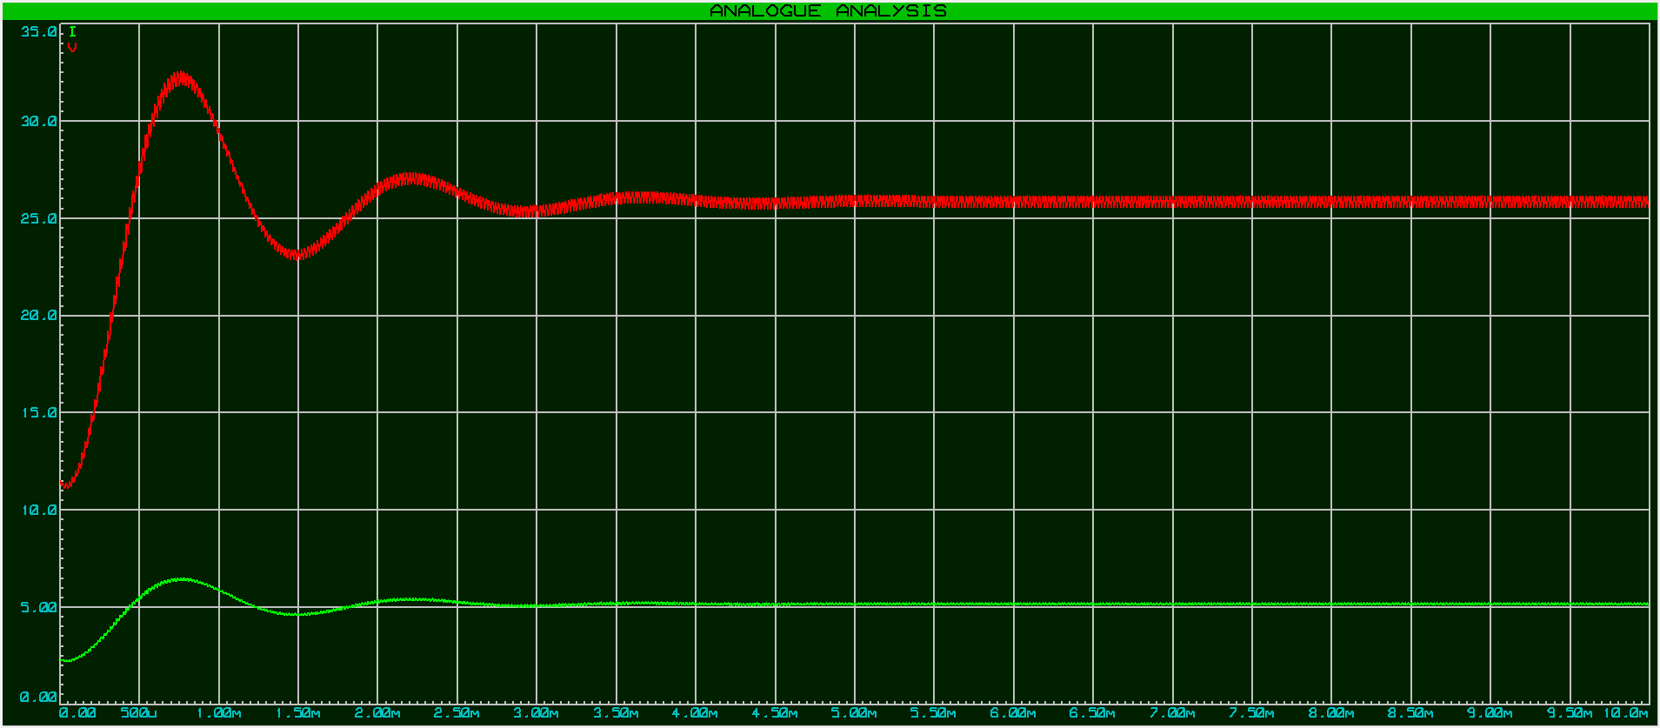

**WORKING**

**Buck Converter**

**Step-1 When MOSFET switch is closed**

When the switching transistor is switched on, it is supplying the load with current. Initially current flow to the load is restricted as energy is also being stored in L1, therefore the current in the load and the charge on C1 builds up gradually during the ‘on’ period. Notice that throughout the on period, there will be a large positive voltage on D1 cathode and so the diode will be reverse biased and therefore play no part in the action.

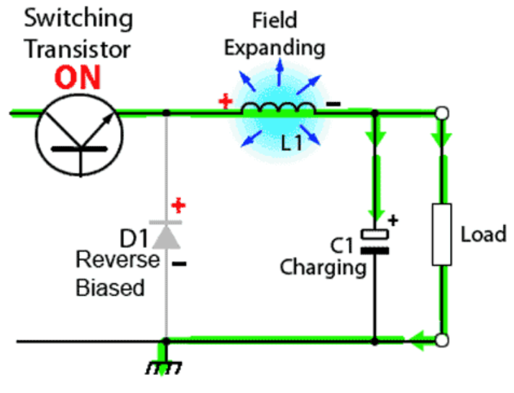

**Step-2 When MOSFET switch is open**

When the transistor switches off the energy stored in the magnetic field around L1 is released back into the circuit. The voltage across the inductor (the back EMF) is now in reverse polarity to the voltage across L1 during the ‘on’ period, and sufficient stored energy is available in the collapsing magnetic field to keep current flowing for at least part of the time the transistor switch is open. The back EMF from L1 now causes current to flow around the circuit via the load and D1, which is now forward biased. Once the inductor has returned a large part of its stored energy to the circuit and the load voltage begins to fall, the charge stored in C1 becomes the main source of current, keeping current flowing through the load until the next ‘on’ period begins.

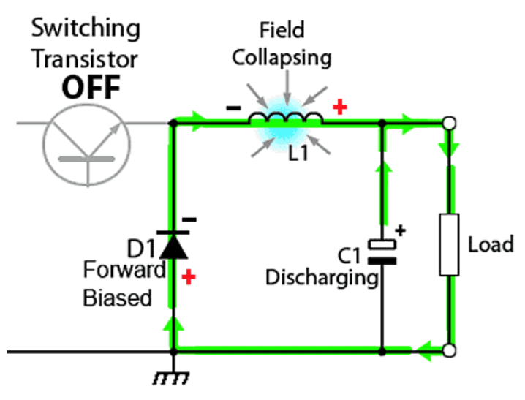

**Boost Converter**

**Step-1 When MOSFET switch is closed**

During this time MOSFET conducts, placing a short circuit from the righthand side of L1 to the negative input supply terminal. Therefore, a current flow between the positive and negative supply terminals through L1, which stores energy in its magnetic field. There is virtually no current flowing in the remainder of the circuit as the combination of D1, C1 and the load represent a much higher impedance than the path directly through the heavily conducting MOSFET.

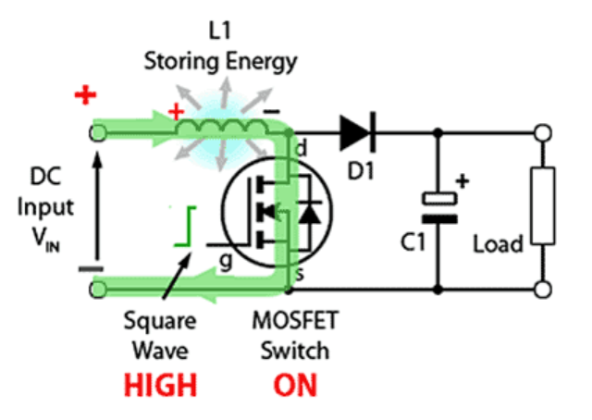

**Step-2 When MOSFET switch is open**

As the MOSFET is rapidly turned off the sudden drop in current causes L1 to produce a back EMF in the opposite polarity to the voltage across L1 during the on period, to keep current flowing. This results in two voltages, the supply voltage VIN and the back EMF (VL) across L1 in series with each other. This higher voltage (VIN +VL), now that there is no current path through the MOSFET, forward biases D1. The resulting current through D1 charges up C1 to VIN +VL minus the small forward voltage drop across D1, and also supplies the load.

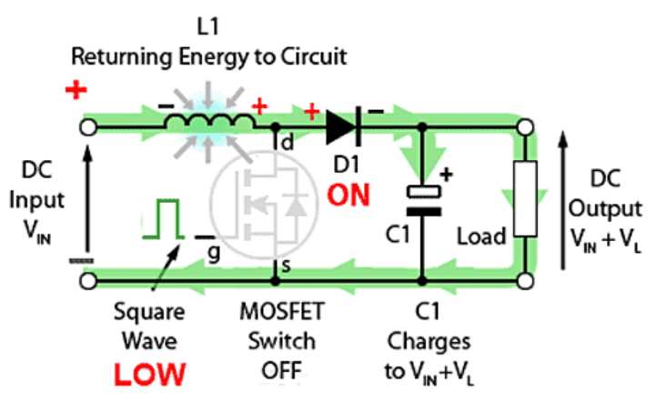

**Step-3 When MOSFET switch is closed again**

Each time the MOSFET conducts, the cathode of D1 is more positive than its anode, due to the charge on C1. D1 is therefore turned off so the output of the circuit is isolated from the input, however the load continues to be supplied with VIN +VL from the charge on C1. Although the charge C1 drains away through the load during this period, C1 is recharged each time the MOSFET switches off, so maintaining an almost steady output voltage across the load.

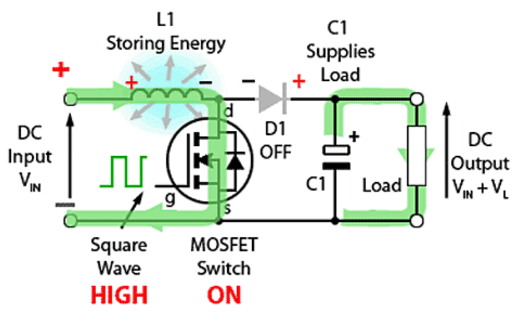

**CONCLUSION**

We have discussed in detail the basic components and working associated with buck converters and boost converters in general. We also managed to simulate both the converters in proteus and managed to get the desired and satisfactory results by follow the due process. In case of buck converter, we managed to step down 12V DC to 5V DC and in the scenario of boost converter we managed to step up 12V DC to 25.6V DC. Hence obtaining desirable results.

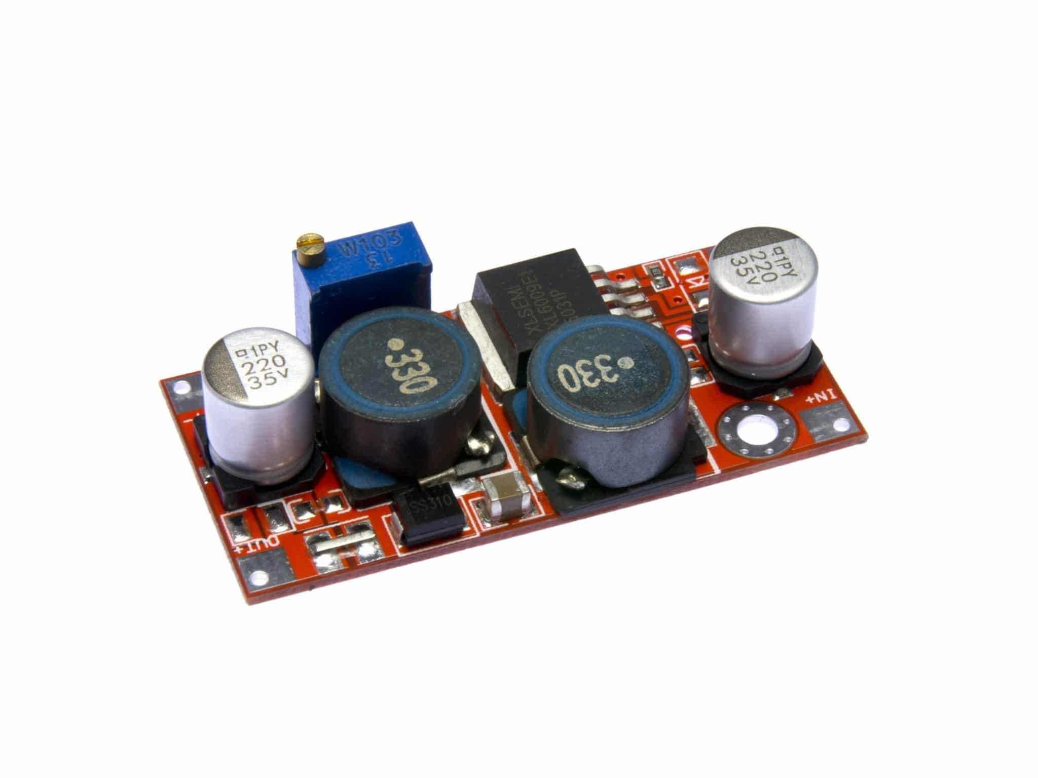

**REFERENCES**

* <https://www.youtube.com/>
* <https://www.digchip.com/>
* <https://learnabout-electronics.org/>
* <https://components101.com/>
* <https://recom-power.com/>
* <https://www.allaboutcircuits.com/>
* <https://www.eeweb.com/>
* <https://www.electrical4u.com/>
* <https://www.ti.com/>
* <https://en.wikipedia.org/>
* <http://www.irf.com/>
* <https://microcontrollerslab.com/>
* <https://www.infineon.com/>
* <https://media.digikey.com/>